NAME : NAVODITAA A.R.
ROLL NO.: 241901071

Exercise 6

IMPLEMENTATION OF PACKET SNIFFING USING RAW SOCKETS IN PYTHON
INTRODUCTION:
Packet sniffing reads raw network packets from your NIC so you can see headers (Ethernet/IP/TCP/UDP) and a bit of payload. This simple experiment uses Linux raw sockets to capture and print a brief summary for each IPv4 packet.
AIM:
Write a minimal Python program that captures packets using a raw socket and prints source/destination IP, protocol, ports (if TCP/UDP) and a short hex dump of the payload.
ALGORITHM :
1. Open a raw AF_PACKET socket (capture all EtherTypes).
2. Loop: receive a packet.
3. Parse Ethernet header; if IPv4, parse IP header.
4. If TCP/UDP, parse ports. Print a one-line summary + short hex of payload.
5. Repeat until Ctrl+C.
CODE:
import socket
import struct
import binascii
import textwrap

def main():
host = socket.gethostbyname(socket.gethostname())
print('IP: {}'.format(host))
conn = socket.socket(socket.AF_INET, socket.SOCK_RAW, socket.IPPROTO_IP)
conn.bind((host, 0))
conn.setsockopt(socket.IPPROTO_IP, socket.IP_HDRINCL, 1)
conn.ioctl(socket.SIO_RCVALL, socket.RCVALL_ON)
while True:
raw_data, addr = conn.recvfrom(65536)
dest_mac, src_mac, eth_proto, data = ethernet_frame(raw_data)
print('\nEthernet Frame:')
print("Destination MAC: {}".format(dest_mac))
print("Source MAC: {}".format(src_mac))
print("Protocol: {}".format(eth_proto))

def ethernet_frame(data):
dest_mac, src_mac, proto = struct.unpack('!6s6s2s', data[:14])
return get_mac_addr(dest_mac), get_mac_addr(src_mac), get_protocol(proto), data[14:]

def get_mac_addr(bytes_addr):
bytes_str = map('{:02x}'.format, bytes_addr)
mac_address = ':'.join(bytes_str).upper()
return mac_address

def get_protocol(bytes_proto):
bytes_str = map('{:02x}'.format, bytes_proto)
protocol = ''.join(bytes_str).upper()
return protocol
main()

OUTPUT:
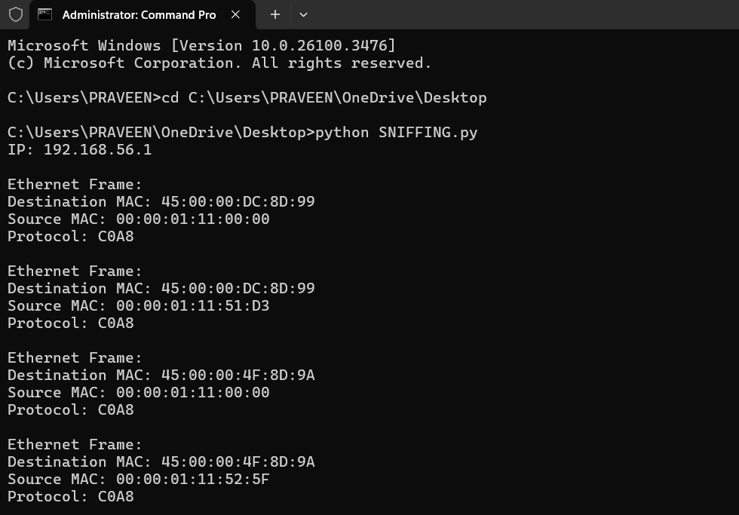
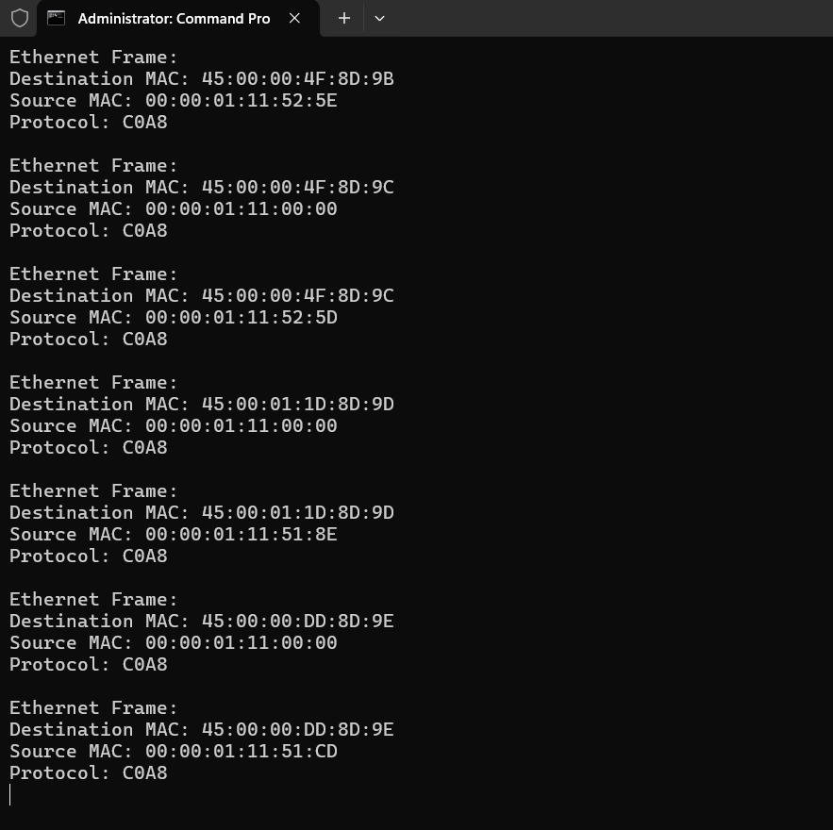

RESULT:
The Python program for packet sniffing using raw sockets was executed successfully.
It captured live network packets and displayed the source IP, destination IP, protocol type, port numbers, and part of the data in hexadecimal form.

